# Practical 2 Design an HTML page with ordered list, unordered list, definition list and nested lists.

## Ordered List

<html>

<head> <title></title> </head>

<body>

<h3>Kaustubh Wade(160410116050)</h3>

<p align="center">Ordered List</p>

<ol> List of Countries

<li> India

<li> USA

<li> UK

</ul>

</body>

</html>

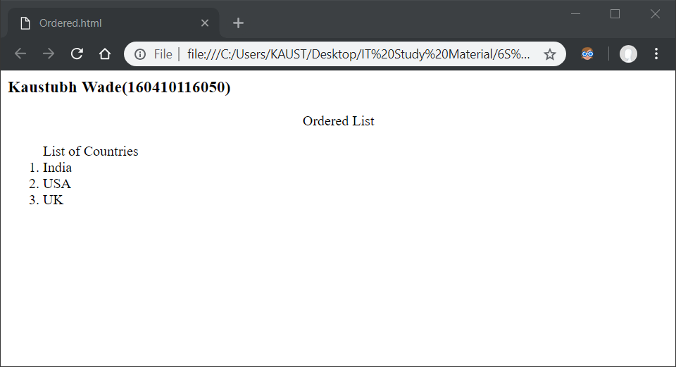

## Unordered List

<html>

<head> <title></title> </head>

<body>

<h3>Kaustubh Wade(160410116050)</h3>

<p align="center">Unordered List</p>

<ul> List of Countries

<li> India

<li> USA

<li> UK

</ul>

</body>

</html>

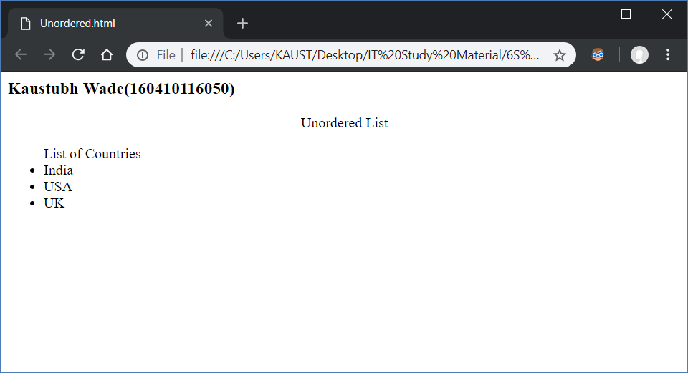

## Definition List

<html>

<head> <title> </title> </head>

<body>

<h3>Kaustubh Wade(160410116050)</h3>

<p align="center">Definition List</p>

<dl> Contents

<dt> Chapter 1

<dd> Topic 1

<dd> Topic 2

<dd> Topic 3

<dt> Chapter 2

<dd> Topic 1

<dd> Topic 2

<dt> Chapter 3

<dd> Topic 1

<dd> Topic 2

</ul>

</body>

</html>

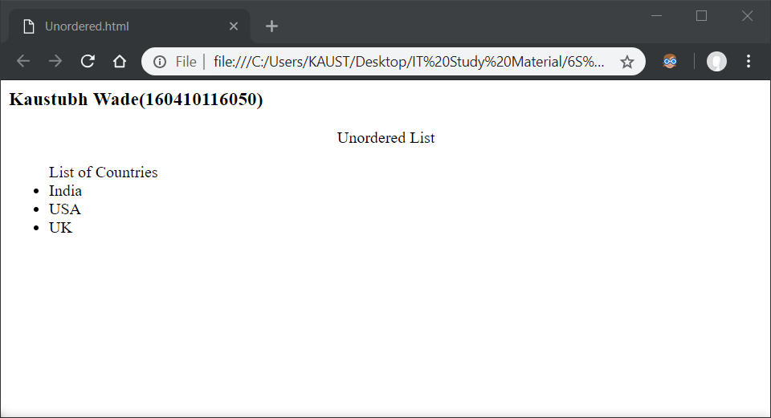

## Unordered List inside Ordered List

<html>

<head> <title> </title> </head>

<body>

<h3>Kaustubh Wade(160410116050)</h3>

<p align="center">Unordered List inside Ordered List</p>

<ol> Contents

<li> Topic 1

<li> Topic 2

<li> Topic 3

<ul> Topic 4

<li> SubTopic 1

<li> SubTopic 2

</ul>

<li> Topic 5

</ol>

</body>

</html>

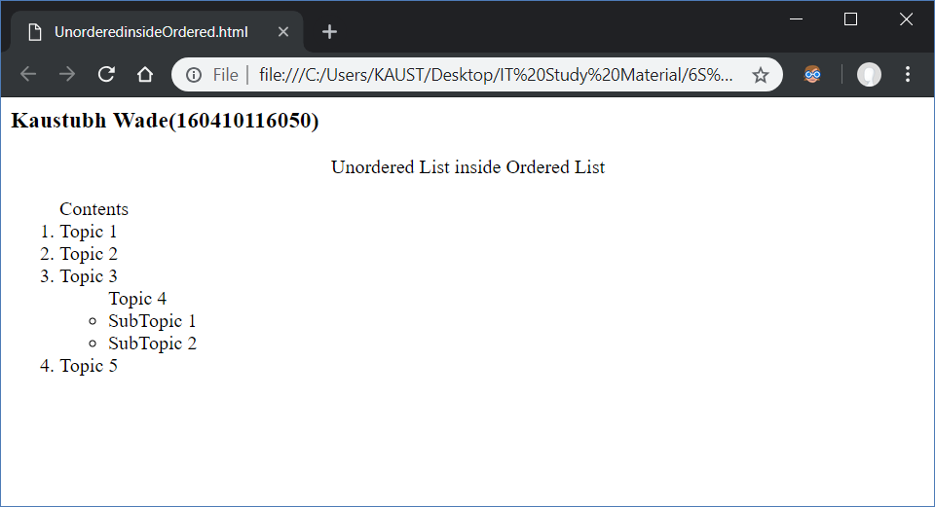

## Ordered List inside Unordered List

<html>

<head> <title> </title> </head>

<body>

<h3>Kaustubh Wade(160410116050)</h3>

<p align="center">Unordered List inside Ordered List</p>

<ol> Contents

<li> Topic 1

<li> Topic 2

<li> Topic 3

<ul> Topic 4

<li> SubTopic 1

<li> SubTopic 2

</ul>

<li> Topic 5

</ol>

</body>

</html>

